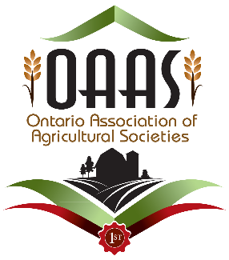**First Impressions Program**

**2019**

**What is the first impression your visitors have of your fair?**

Is it great or could it use some tweaking?  
Is there great signage showing them how to find your fair and attractions within the fair?  
Do you have interesting entertainment and is there something for everyone?  
Does your venue promote agriculture and Rural Ontario?  
Is your venue accessible and hazard free?  
Are there lots of food choices and do you have ample parking?

If you are interested in knowing what your fair's 'first impression' is, then you should consider participating in the "***OAAS First Impressions*** " program. This unique program offers the opportunity to look at your fair through the eyes of others.

It is a tremendous chance to identify areas for improvement that will enhance your guests' experience at your fair.

* We all know that first impressions are the ones that last and become memories. Help your fair create positive lasting first impressions by participating in this unique program.
* Agricultural Societies are paired with another fair. A team from each Agricultural 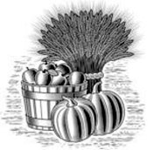Society visits the other's fair and evaluates specific characteristics based on the visitors' "first impressions"
* The feedback from these visits validates the areas the society is doing a terrific job and identifies areas for improvement.
* It identifies areas where you might grow your fair.
* This program builds strong relationships among fairs and fair boards and gives concrete information to support strategic planning.

**Complete the application form available on OAAS website.**

[www.ontarioagsocieties.com/member-services/first-impression-program](http://www.ontarioagsocieties.com/member-services/first-impression-program)

Email: [firstimpressions@oaasfairs.com](mailto:firstimpressions@oaasfairs.com)

**Application deadline is May 1st, 201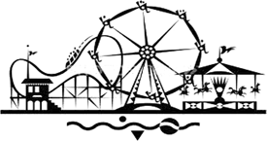9**

Presentations must be completed by November 1st, 2019 for reimbursement of your Participation fee.

**OAAS First Impressions**

**Application Form 2019**

**Name of Fair**: Click to enter name of your fair.

**Name of Agricultural Society**: Click to enter the name of your Agricultural Society.

**Fair Dates for 2019**:Click to enter Fair dates.

**District:** Click to enter District number.

**Contact Person 1**:Click to enter First and Last name of Contact 1.

**Address**: Click to enter Contact 1 mailing address.

**Postal Code**: Click to enter postal code.

**Email Address**: Click to enter Contact 1 email address.

**Phone Number**: Click to enter phone number.

**Contact Person 2**:Click to enter First and Last name of Contact 2.

**Address:** Click to enter Contact 2 mailing address.

**Postal Co**de: Click to enter postal code.

**Email Address**:Click to add Contact 2 email address.

**Phone Number**: Click to enter phone number.

**Number of Days Fair Held**: Click to enter number of days.

**Attendance at Fair**: Click to enter number attending

**Fair Start Date and Time**: Click to enter Fair Start Date and Time.

**Fair Closing Date and Time**: Click to enter Fair Close Date and Time.

**Please mark off all the following categories that apply to your fair:**

**Livestock**

Livestock classes: Yes No

4-H Show: Yes No

Other: Click to enter more information.

**Homecraft**

Hall Exhibits: Yes No Other: Click to enter further information.

**Entertainment**

Tractor/Truck Pull/Demolition Derby: Yes No

Midway: Yes No

Commercial Vendors: Yes No Other: Click to enter further information.

Because OAAS believes in the value of the “First Impressions” program and wishes to encourage more participation by fairs that may not be able to afford the program, once your Agricultural Society has completed all parts of the program, your fees will be refunded to your association.

A participation fee of $113.00 ($100.00 + HST) is payable to the “*Ontario Association of Agricultural Societies*” when you submit your application send payment to: **OAAS 1911 Foxboro Stirling Rd R.R.# 4 Stirling, ON K0K 3E0**. Once you have been paired with another fair and you do not participate, there will be no refund. **Presentations must be completed by November 1st, 2019 for reimbursement of your Participation fee**. In addition to the participation fee, each society will be responsible for providing passes to the visiting fair volunteers as well as their own travel costs, photocopying and /or printing and incidentals of volunteers.

**Application deadline for the 2019 First Impressions program is May 1st, 2019**

Application to be completed and submitted electronically ONLY to:

[firstimpressions@oaasfairs.com](mailto:firstimpressions@ontariofairs.com)